Carnivore’s Christmas Guide
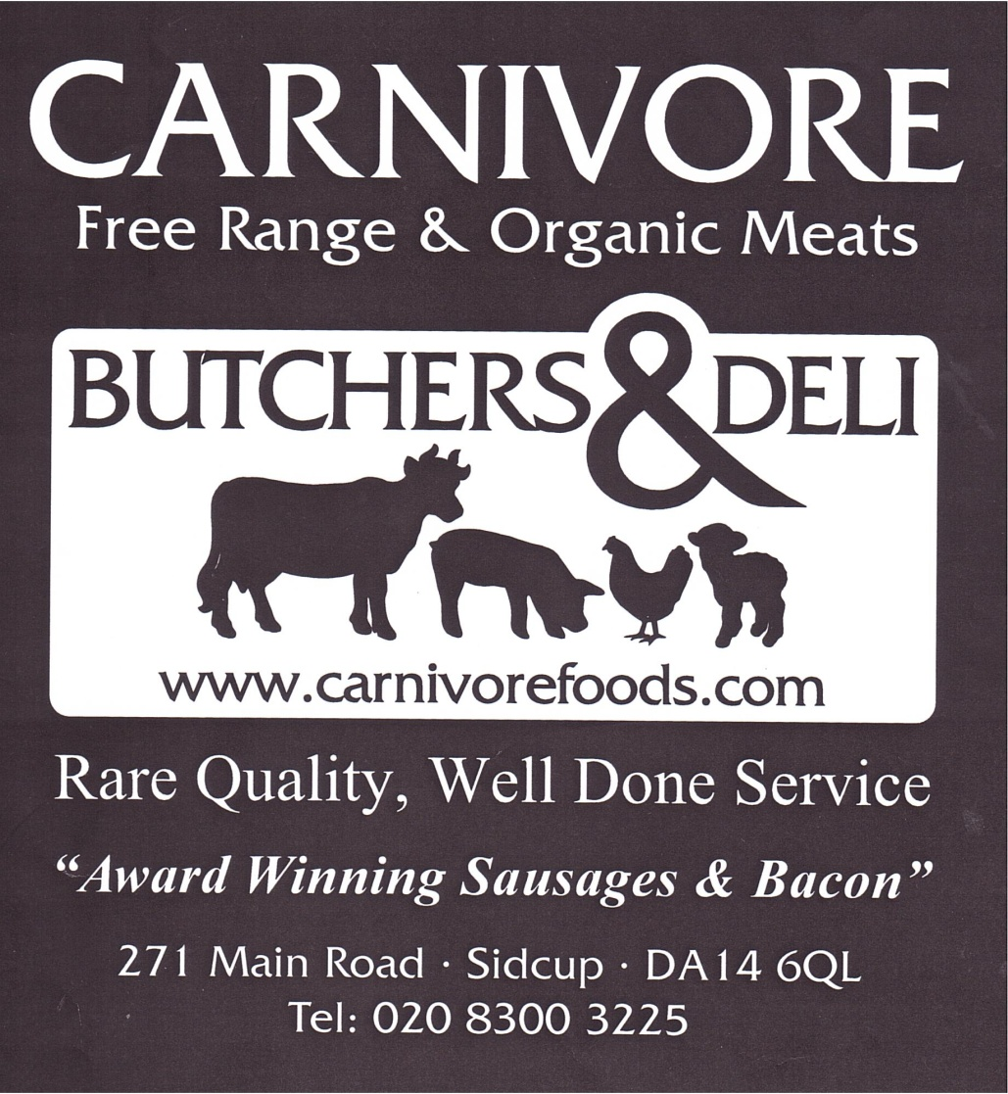

Here is a short guide to help you when placing your order for Christmas, this doesn’t show our full range, so if there is anything not on the list please ask and we will be happy to advise.
Orders can also be placed over the phone, but please be advised that it may take a while to get through at this time of year.
Thanks for considering us for your most important meal of the year

Free range Bronze Turkeys
Our turkeys are a special slow growing traditional breed which are
Raised to full adult maturity (hence 5kg starting weight).
Fully mature turkeys have the benefit of a deliciously dense meat, along
With a natural fat layer under the skin which helps retain moisture
Whilst cooking (succulence without the need for basting)

In December, our turkeys are dry plucked by hand & game hung for at least two weeks in the centuries old way. This enables the rich, traditional flavour to develop fully, ensuring the finest taste & texture for Christmas day.

Size Suggestion
500g should be allowed per serving
5kg = 8 -10 Servings, 5-6kg = 10 – 12 Servings, 6-7kg = 12 – 14 Servings,
7-8kg = 14 – 16 Servings, 8-9kg = 16 – 18 Servings,
Larger Turkeys also available.
Turkey Butterfly’s
Boneless Turkey breast can also be prepared to whatever size required, these will come dressed & tied in Pancetta (Italian smoked streaky bacon) as standard, but can also come stuffed with one of our delicious stuffing or naked according to your preference.

Turkey Crowns
Bone in Turkey Breast, with the legs & heavy bones removed. Please ask in store for advice
Judy Goodman’s Free range Geese

All the geese are hatched from April to July and are reared on an
Extensive free range system. The geese graze over large grass
Paddocks and are fed on all natural foods: grass, corn, straw and a
Specially prepared ration containing no additives or growth promoters.

Small (4kg) = 4 servings.
Medium (5kg) = 6 servings.
Large (6kg) = 8 servings.

Free range Chickens and Capons

Three generations of the Caldecott family have farmed the land in Wythall, Worcestershire, Today Robert, produces a "real" free range chicken, the Caldecott's Cotswold White Free Range Chicken, a slow growing breed originating from the Rhode Island Red and the Cornish White Game.

2 - 3Kg = 4 - 6 servings.
3 – 4Kg = 6 - 8 servings.
4 - 5 Kg = 8 - 10 servings.
Ducks

English Free range, & French Barbary ducks available.
2 - 2.5kg = 4 servings.
2.5 - 3kg = 5 servings.
3+ kg = 6 serving
Game
A wide range of game is available, please ask in store for details.

Bird in a bird

5 Bird Roasts: Goose+turkey+duck+guinea fowl+pheasant serves 16 - 20 £178.00

4 Bird Roasts: Turkey+duck+guinea fowl+pheasant serves 12 - 16 £99.90

3 Bird Roasts: Chicken+duck+pheasant serves 8 – 10 £49.80

3 Bird Breast Roast: Turkey+Duck+Pheasant serves 6 – 8 £35.00

Please ask for other options for multi bird roasts

Beef

Our Beef comes from Traditional Native Breeds & is matured for a minimum of 28 days, please ask for sizing when ordering. All cuts available.

Lamb

Free-range or Organic Lamb, matured for minimum 14 days

Sausages

Our award winning sausages are hand made on the premises.
They are made in small batches to a precise recipe to ensure a consistently high quality: only the finest ingredients are used, from using only choice cuts from the same free-range meats you can see on display, to the freshest herbs.

Sausages 6 per pack.
Chipolatas12 per pack.
Cocktails 24 per pack
Pigs in Blankets 20 per pack

Varieties

Traditional, Traditional Chipolatas & Cocktails, Fresh Herb, Kloneddy’s, Fresh Leek, Stilton with Charcoal Cracker, Italian, Toulouse, Organic Beef with Horseradish, Moroccan Lamb with Prune & Apricot, Honey & Mustard, Venison with Red Wine, Negril Jerk, Merguez, Boerewors, Bramley Apple

Home-made stuffing’s

Our special Christmas stuffing’s are all Homemade in small batches to a precise recipe to ensure a consistent high quality: only the finest
Ingredients are used.
All contain free range pork sausage meat, chunky bread crumbs, and pancetta (except for the traditional sausage meat). 500g Packs

Varieties

Home-made Free-range sausage meat,
Fresh sage & red onion,
Cranberry and orange,
Fresh roasted chestnut, with sultana and brandy

Dry Cured Gammon (uncooked)

Our Organic or Free-range gammons are dry cured on the premises and available smoked or unsmoked. Gammon is the name for cured leg of Pork before it is cooked and should not be confused with Ham when ordering.

Boneless joints: allow approx. 500g per serving ie
2kg = 6 - 8 servings. 3kg = 8 - 12 servings. 4kg=12 - 16 servings.
5kg= 16 - 20 servings.

Bone in Gammon:
4kg = 8 - 10 servings
5kg = 10 – 12 servings
6kg = 12 - 16 servings
7kg = 16 - 20 servings.
8kg+=20+ servings.

Bacon

Traditional Free range bacon dry cured on the premises 500g packs

Back Bacon; Smoked, Unsmoked, or Treacle Cured
Streaky; Smoked or Unsmoked
Cooked Ham
Our organic and free range hams are dry cured and cooked on the premises. They come either on or off the bone and are available in a number of varieties.

Varieties
Smoked; honey roast, mustard roast, traditional plain, traditional breaded.

Hams on the bone:

Come either whole or half, and range in weight between
2.5 - 3kg for a small half ham, and up to a large 7kg ham. This will give between 8 and 30 servings.

Hams off the bone

Are available cut to any size you require, but please bear in mind any joint less than 1.5kg will look more like a thick slice than a joint. 170g per serving should be allowed.

Stocks
For the perfect gravy or sauces, fresh home-made unsalted stocks are available in: Turkey, Chicken, Beef, Veal and Lamb

Cheese Boards

Classic cheese board.

£3.95 per head, minimum of 4 people.

Montgomery’s Cheddar
Mature cheddar from Somerset, a standard bearer of
English farmhouse cheddars.

Cropwell Bishop Stilton
An excellent prize winning blue
Stilton with a firm, creamy paste and mature flavour.

Brie de Meaux
A wonderful brie, creamy and full flavoured

Posh George’s special selection

£5.95 per head, minimum of 4 people.

Vacherin Mont D’or

A unique cheese with an almost runny consistency and a rich, creamy flavour.

Cropwell Bishop Stilton

An excellent prize winning blue
stilton with a firm, creamy paste and mature flavour.

Godminster Organic Cheddar

In its distinctive purple wax this organic cheddar is a
powerful cheese with a real edge to it.

Individual Goats Cheese

One of Carnivore’s delicious artisan Goats cheeses

Name…………………………………………………………
Address………………………………………………………
Post code……………………………………………………..
Telephone……………………………………………………
Email…………………………………………………………
Pickup Date………………………………………………….
Reward Card Number………………………………………..
Item | Weight /  Number | Variety | Special instructions

Note: This is not an order form, It is designed to speed up the ordering process. Please Visit or Call to place your Order, Orders dropped off or posted will not be processed

